Health, Safety & Wellbeing Policy

This is the Health, Safety & Wellbeing Policy Statement of Smart Managed Solutions A Trading Name of HR Facilities Limited

# General Statement of Policy

Smart Managed Solutions are dedicated to safeguarding the health, both mental & physical, & safety of its employees as we understand this is an integral element of a successful and efficient business. The management of this key performance indicator is therefore central to our strategy for the wellbeing of the Company, its employees, and the prevention of injury and ill health. We acknowledge Health & Safety is management responsibility and are of equal importance to all other parts of the business. It is to be actively pursued through the continuing development of employee competence and the provision of expert advice to achieve progressive improvements in Health & Safety performance. As a company we are committed to ensuring compliance with the requirements of The Health and Safety at Work Act etc.1974 and other such relevant Health and Safety related legislation that is applicable to the scope of our business and activities of it’s employees. We will therefore strive to ensure, so far as is reasonably practicable that: -

* All relevant statutory requirements are observed and are treated as the minimum standards to be applied to any work activities.
* Health & Safety considerations are included in our business planning and decision making. Thus, ensuring a safe and healthy working environment along with safe methods of work and conditions are provided, adopted and managed.
* Adequate information, instruction, training and supervision is to be provided so that through the use of formal risk assessment and the communication of the control measures to be adopted, to eliminate or reduce risk, individuals are made aware of the potential hazards they may face as a consequence of their work and work of others.
* Plant, equipment and materials provided for work that is to be undertaken will be fit for purpose and adequately maintained so as to be free from unnecessary risk.
* Employees and Sub-Contractors are actively encouraged to raise any health or safety concerns and submit ideas and suggestions for improving standards, thereby facilitating co-operation between individuals, groups and the management team.
* The immediate and underlying causes of work-related injuries and near misses will be identified, and the necessary preventive action implemented to prevent a re-occurrence. This will include, as a last option, the provision and use of the correct personal protective equipment to ensure the health and safety of all whom may be affected.
* The Health, Safety and Wellbeing of employees and those whom may be affected by their actions will never be compromised for any company objectives.

To assist in the promotion of a positive Health, Safety and Welfare culture the Company will establish objectives; develop, implement, and maintain management controls; instigate sound communication of information on safety and health; monitor; audit and review matters of Health and Safety & Welfare. In pursuance to that Health, Safety and Welfare will therefore be regularly reviewed at a senior level.

This Policy will be reviewed and developed annually or when required through circumstantial change to ensure it remains effective, communicated to all employees and made available to interested parties when required.

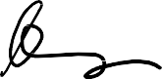 Date: 15/05/2024

Name: Lee Metcalfe Position: C.E.O

|  |  |  |  |
| --- | --- | --- | --- |
| Document Ref: QHS - 001 | Original Issue Date:       05.04.2017 | Review frequency: Annual | Current Version:    09 |

# Organisation for carrying out the policy

Overall responsibility for health and safety rests firmly with Lee Metcalfe – Managing Director. However, ALL individuals within the workforce must accept a certain duty of care for health and safety towards themselves and others who might be affected by their acts or omissions.

The Managing Director with the close support of the QHSE Director and Senior Management Team (SMT) is committed to supporting and continually improving standards regarding health, safety and welfare within the company, and will:

* Ensure suitable financial provision is made for health & safety obligations
* Provide appropriate information and instruction to employees
* Ensure work is planned to consider health & safety issues
* Ensure that staff at all levels receive appropriate training
* Monitor and assess risk to health and safety
* Understand the company policy for health and safety and ensure it is readily available for employees
* Set a personal example when visiting site by wearing appropriate protective equipment
* Actively promote at all levels the company’s commitment to effective health and safety management

# Health and Safety Responsibility

The person responsible for H&S is Lee Metcalfe.

The QHSE Director shall cover day to day management for Smart Managed Solutions regarding:

* Monitoring the implementation of the health and safety policy throughout the company and reviewing its appropriateness by regular safety audits/inspections carried out in various workplaces
* Investigating accidents, incidents and near misses and implementing corrective action
* Reviewing health and safety legislation and implementing any new requirements pertaining to the company’s undertaking
* Liaising with managers, employees, sub-contractors and specialists as and when appropriate
* Collating and reporting any accidents reportable under the Reporting of Injuries, Diseases and Dangerous Occurrences Regulations (R.I.D.D.O.R.) 2013
* Manage continual improvement

# Employees

Section 7 of the Health and Safety at Work Act 1974 states the following: It shall be the duty of every employee while at work to:

* Take reasonable care for the health and safety of him/herself and of other persons who may be affected by his / her acts or omissions at work; and as regards any duty or requirement imposed on his / her employer or any other person by or under any of the relevant statutory provisions, to co-operate with him / her so far as is necessary to enable that duty or requirement to be performed or complied with.
* Report any accidents, incidents, near misses or defects / deficiencies in work equipment immediately to their line manager.
* Raise concerns immediately, regarding their own or others wellbeing or mental health.
* You must NOT interfere in any way, shape or form with anything provided to safeguard yourself and / or others.
* Please remember: Any interference, neglect or infringement of statutory regulations or Smart Managed Solutions Safety Risk Assessments, Method Statements, Rules, Policies and procedures will be treated as a disciplinary matter and may be treated as gross misconduct.

|  |  |  |  |
| --- | --- | --- | --- |
| Document Ref: QHS - 001 | Original Issue Date:       05.04.2017 | Review frequency: Annual | Current Version:    09 |

# For all employees to comply with their legal duties, they will undertake and be responsible for:

* Reading and understanding the Company’s health and safety policy and carry out their work safely and in accordance with its requirements.
* Ensuring that all protective equipment provided under a legal requirement is properly used in relation to any instruction / training given and in accordance with this health and safety policy.
* Ensuring Internal E-Learning modules are completed promptly, and information followed fully at all times.
* Reporting any defects to work equipment immediately to the Site Supervisor / line manager.
* Reporting to the management any incidents, which have led or might lead to injury or damage.
* Reporting any accidents or near misses however minor to the Site Supervisor / line manager.
* Using the correct tools and equipment for the job in hand and in accordance with training and instructions
* Co-operating with any investigation, which may be undertaken with the objective of preventing reoccurrence of incidents.

# Arrangements for health, safety and wellbeing

Smart Managed Solutions Health and Safety policy is reviewed annually and is made available to all direct employees and sub-contractors who are required to confirm that they have received it and understands its requirements.

# Staff Wellbeing arrangements

Smart Managed Solutions Senior Management recognise that promoting positive mental health and actively supporting the reduction of stress related illness is paramount. Smart Managed Solutions are committed to addressing issues that may present a risk to our employee’s wellbeing. The below Wellbeing Support framework has been developed in order to provide our employees with clear information that can direct them to reach out for help at any time.

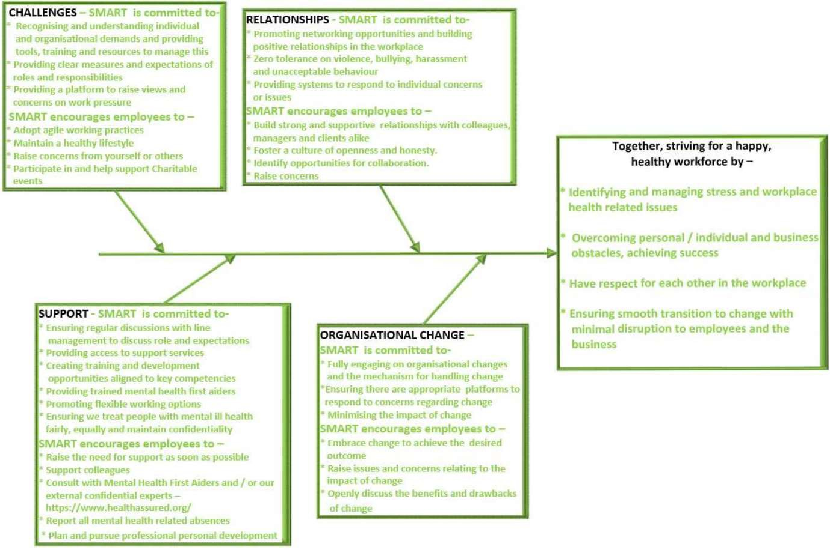

|  |  |  |  |
| --- | --- | --- | --- |
| Document Ref: QHS - 001 | Original Issue Date:       05.04.2017 | Review frequency: Annual | Current Version:    09 |

# Communication/Consultation

In order to meet the legal requirements of the Safety Representatives and Safety Committees Regulations and the Health and Safety (Consultation with Employees) Regulations, the company will communicate and consult with employees on the following issues:

* The content of this policy
* Any rules specific to a site or job
* Changes in legislation or working best practice
* The planning of Health and Safety training
* The introduction or alteration of new work equipment or technology

This communication and consultation will take place with the employees via internal email, training, Health and Safety bulletins.

# Training

All employees are given training appropriate to their responsibilities in accordance with the Management of Health and Safety at Work Regulations. Training will be provided for the following situations:

* Induction training for new employees
* The introduction or modification of new/existing machinery or technology
* A change in employee position/work activity or responsibility.
* Internal E-Learning Training Courses and Toolbox talks.

Training required for individuals will be identified, arranged and monitored by that individual’s manager, Business Unit Director and the QHSE Director. Job or site-specific training required for individuals to conduct a task competently and safely shall also be identified, arranged and monitored by that individual’s manager.

* Tasks which require specialised training include –
* Risk Assessing
* Mental Health & Wellbeing
* Low Voltage & High Voltage Electrical Systems
* Confined Space Work
* Work at Height
* First Aid
* Fire Marshall / Safety

A programme of refresher training will be undertaken to keep employees up to date with legislation and industry best practice.

# Emergencies and Fire

It is the Company’s policy to take account of fire hazards in the workplace. All employees have a duty to conduct their operations in such a way as to minimise the risk of fire. This involves compliance with the Company’s no smoking policy, keeping combustible materials separate from sources of ignition and avoiding unnecessary accumulation of combustible materials. Site Supervisors are responsible for keeping their operating areas safe from fire, ensuring that their staff are suitably informed in fire prevention practices and emergency procedures. Pertinent fire safety information shall be relayed to all Smart Managed Solutions site personnel and visitors via a site induction. All fire safety equipment and systems including Fire extinguishers, alarms, suppression systems, dry risers,

|  |  |  |  |
| --- | --- | --- | --- |
| Document Ref: QHS - 001 | Original Issue Date:       05.04.2017 | Review frequency: Annual | Current Version:    09 |

dampeners shall be maintained in accordance with statutory requirements. An emergency fire evacuation drill shall be conducted and recorded at least once a year.

# Staff Welfare

Wherever possible arrangements will be made with the Client and/or Principal Contractor for the use of Welfare facilities at sites under their management. As a minimum the following requirements will be adhered to:

* Toilet/washing facilities accessible on site
* Eating/rest facilities accessible on site

Where these facilities are not provided by the Client or Principal contactor, the company will provide suitable welfare facilities, work Equipment and Plant.

All work equipment (including electrical equipment) used at work, as part of the Company’s undertaking will comply with the Provision and Use of Work Equipment Regulations (P.U.W.E.R.) Before new equipment is introduced into the working environment and assessment will be made by a suitable person, in order to ascertain that the equipment is suitable for its intended use.

No employee will use work equipment for which they have not received specific training.

No employee will knowingly misuse work equipment or remove any guards that are in place to minimise a specified risk.

All work equipment will be maintained and inspected at suitable intervals either internally by a competent person or by specialist external companies. The frequency of work equipment maintenance or inspection will be based on manufacturer’s guidance and industry best practice. Any maintenance / inspections undertaken on company equipment will be formally recorded with a hard copy left on file.

If any faults or damage are found on any equipment, stop using the work equipment and report the fault to your Supervisor. Equipment shall then be removed from service and secured away until adequate repair has been completed. If repair is not possible the equipment shall be disposed of through the correct channels at the earliest convenience.

# Personal Protective Equipment (PPE)

Smart Managed Solutions shall ensure adherence with the Personal Protective Equipment at Work (amendment) Regulations 2022. So far as reasonably practicable, appropriate personal protective equipment will be issued to employees as and when necessary for work activities. Training will be provided for employees on the safe use, storage and maintenance of the relevant equipment. Employees have a legal duty to wear PPE as specified in relevant site rules, risk assessments and method statements and training. Any defects or malfunction of PPE must be reported to your line manager.

# First Aid and Accident Reporting

Adequate first aid provision will be made at every place of work occupied by the Company.

Each first aid box shall be suitably marked and be easily accessible to all employees at all times when they are at work. On Project Sites – wherever possible arrangements are made with clients/clients/principal contractors to use their first aid facilities. Where this is not possible, a member of the project team will be nominated as the appointed person for first aid and a first aid box supplied, which will contain adequate supplies for the total number of employees on site. Head Office – the first aid box is located on the wall next to the office main entrance. The Qualified First Aider / Appointed Person; As indicated by first aid arrangements notice All accidents, incidents or near-misses MUST be reported to your Line Manager and QHSE Director as per the Accident reporting procedure and the details recorded in the accident book. Reporting of Injuries, Diseases and Dangerous Occurrences

|  |  |  |  |
| --- | --- | --- | --- |
| Document Ref: QHS - 001 | Original Issue Date:       05.04.2017 | Review frequency: Annual | Current Version:    09 |

Regulations (R.I.D.D.O.R.): Certain accidents are reportable to the HSE’s Incident Contact Centre. The QHSE Director must be notified as soon as practicable after incidents causing the following injuries:

* any work-related injury that leads to an employee being absent from work for more than 7 working days
* fracture other than to fingers, thumbs or toes;
* amputation;
* dislocation of the shoulder, hip, knee or spine;
* loss of sight (temporary or permanent);
* chemical or hot metal burn to the eye or any penetrating injury to the eye;
* injury resulting from an electric shock or electrical burn leading to unconsciousness or requiring resuscitation or admittance to hospital for more than 24 hours;
* any other injury: leading to hypothermia, heat-induced illness or unconsciousness; or requiring resuscitation; or requiring admittance to hospital for more than 24 hours.
* Death

All accidents / incidents will be investigated by senior management and QHSE Director with the following objectives.

* To determine the cause(s) with a view to preventing a recurrence
* To gather information for use in any criminal or civil proceedings
* To confirm or refute a claim for industrial injury benefit
* To prepare notification to be made to the Health and Safety Executive

The degree of investigation will be dependent on the seriousness of the accident. The aim of the investigation will be to seek to answer the following questions;

* WHAT caused the accident?
* WHO was involved?
* WHEN did it occur?
* WHERE did it occur?
* WHY did it occur? – Root cause analysis
* HOW could it have been prevented?
* HOW will a recurrence be prevented?

# Hazardous Substances (COSHH)

Before any hazardous substances are used during a work process, a material safety data sheet (MSDS) will be requested from the supplier and an appropriate assessment made of the risks from that substance will be undertaken by the user who must have completed the mandatory CoSHH E-Learning module. Alternative less harmful substances will be used wherever possible.

Assessments will consider storage, handling, aspects of use, exposure, PPE requirements, workers health, and emergency actions. Supervisors will brief staff on any hazard or substance precautions, with written records being located in an accessible location within each department.

An inventory of all substances and materials hazardous to health documented within a Logbook.

Health surveillance will be provided when determined as appropriate in the CoSHH assessment. It is the responsibility of Contract, Area, Project Managers to identify hazardous substances and carry out a sufficient assessment. The responsibility for ensuring all actions identified in the assessment are implemented shall be that of the QHSE Director. The QHSE Director shall also ensure that substances can be used safely before purchasing. All CoSHH Assessments shall be reviewed annually by site management.

|  |  |  |  |
| --- | --- | --- | --- |
| Document Ref: QHS - 001 | Original Issue Date:       05.04.2017 | Review frequency: Annual | Current Version:    09 |

# Asbestos

Awareness Training shall be provided to all employees via the Smart Managed Solutions Internal E-Learning Platform frequently. Asbestos records where applicable will be made available upon request and stored within the site logbook.

# Manual Handling

Manual handling operations will be risk assessed to determine suitable control measures for the management of risk and the company will endeavour to eliminate manual handling operations where practicable with any remaining risks being controlled by;

* training in Manual Handling
* reducing weights
* reducing the frequency of manual handling
* the use of additional manpower
* through the provision of suitable equipment to assist in the operation
* the selection of persons to carry out manual handling or lifting tasks will be based on the training given, age, physique etc.

# Co-operation and Coordination

Employees will always familiarise themselves with client procedures when first attending site, in particular general site access, emergency procedures and high-risk work activities including permit to work systems. Clients site procedures and specific instructions will be followed at all times. Before commencing work, the site supervisor will attend any site meetings or inform other trades working in the direct vicinity of the activities of the company of the specific risks and requirements of the work being undertaken.

# Risk Assessments

Various types of Risk assessments are carried out continuously by employees throughout their work. Hazards are considered and work methods established to minimize the risk of injury to themselves, and others affected by the work. Where the employee does not have enough knowledge about a specific hazard, such as work in confined spaces, they will take further advice from the QHSE Director if required.

The Managing Director ensures employees are provided with appropriate instruction and training on risk assessments.

# Staff Consultation

Smart Managed Solutions encourages consultation with staff to ensure:

* That the Company meet their duties under the Safety Representatives and Safety Committees Regulations 1977 and the Health and Safety (Consultation with Employees) Regulations 1996.
* That open communicate and consultation with all employees is ongoing with regard the following issues: - The content of the policy - Any rules specific to a site or job - Changes in legislation or working best practice
* That health and safety training is ongoing
* That the introduction or alteration of new work equipment or technology is corrected communicated.

# Statutory Compliance

Senior management shall ensure compliance with legislation applicable to the scope of the business operation is effectively maintained. Compliance with all statutory requirements shall be maintained through internal audit procedure. Audit results are published weekly to the Senior Management Team to communicate and monitor non- conformities and remedial actions.

|  |  |  |  |
| --- | --- | --- | --- |
| Document Ref: QHS - 001 | Original Issue Date:       05.04.2017 | Review frequency: Annual | Current Version:    09 |

# Projects

Under the direction of the project's director, and supported by senior management Smart Managed Solutions will ensure the following is adhered to, so far as reasonably practicable –

* Make sure the client is aware of the client duties under CDM 2015 before any work starts
* Plan, manage and monitor all work carried out by ourselves and our workers, taking into account the risks to anyone who might be affected by it (including members of the public) and the measures needed to protect them.
* Check that all workers we employ or appoint have the skills, knowledge, training and experience to carry out the work, or are in the process of obtaining them.
* Make sure that all workers under our control have a suitable, site-specific induction, unless this has already been provided by the principal contractor
* Provide appropriate supervision, information and instructions to workers under their control
* Ensure they do not start work on site unless reasonable steps have been taken to prevent unauthorised access
* Ensure suitable welfare facilities are provided from the start for workers under their control and maintain them throughout the work.

In addition to the above responsibilities, where Smart Managed Solutions may be working on projects involving more than one contractor will:

* Coordinate our work with the work of others in the project team
* Comply with directions given by the principal designer or principal contractor
* Comply with parts of the construction phase plan relevant to our work
* When required, will ensure a thorough Construction Phase Plan is in place

# Policy review

This policy will be kept up to date, particularly as the business changes in nature and size. To ensure this, the policy and the way in which it has implemented will be reviewed every year or when required through circumstantial change.

# How the policy is brought to the attention of employees

When they join the company, all employees are asked to sign to confirm that they have read the policy statement, and this is repeated on an annual basis electronically via the Smart Internal E-Learning Platform. A hard copy is available on the H&S Board, a copy is also available on every site within the Logbook system. Employees are also made aware of:

* how to report an accident, incident or near miss
* what to do in the event of fire or emergency
* informed of who their first aiders are

# Authorisation of this policy

The policy is authorised by the C.E.O and checked annually or when required through circumstantial change by the QHSE Director.

|  |  |  |  |
| --- | --- | --- | --- |
| Document Ref: QHS - 001 | Original Issue Date:       05.04.2017 | Review frequency: Annual | Current Version:    09 |